**Project Design Phase-II**

**Technology Stack (Architecture & Stack)**

|  |  |
| --- | --- |
| Date | 03 October 2022 |
| Team ID | PNT2022TMID51724 |
| Project Name | VIRTUAL EYE - LIFE GUARD FOR SWIMMING POOLS  TO DETECT ACTIVE DROWNING |
| Maximum Marks | 4 Marks |

**Technical Architecture:**

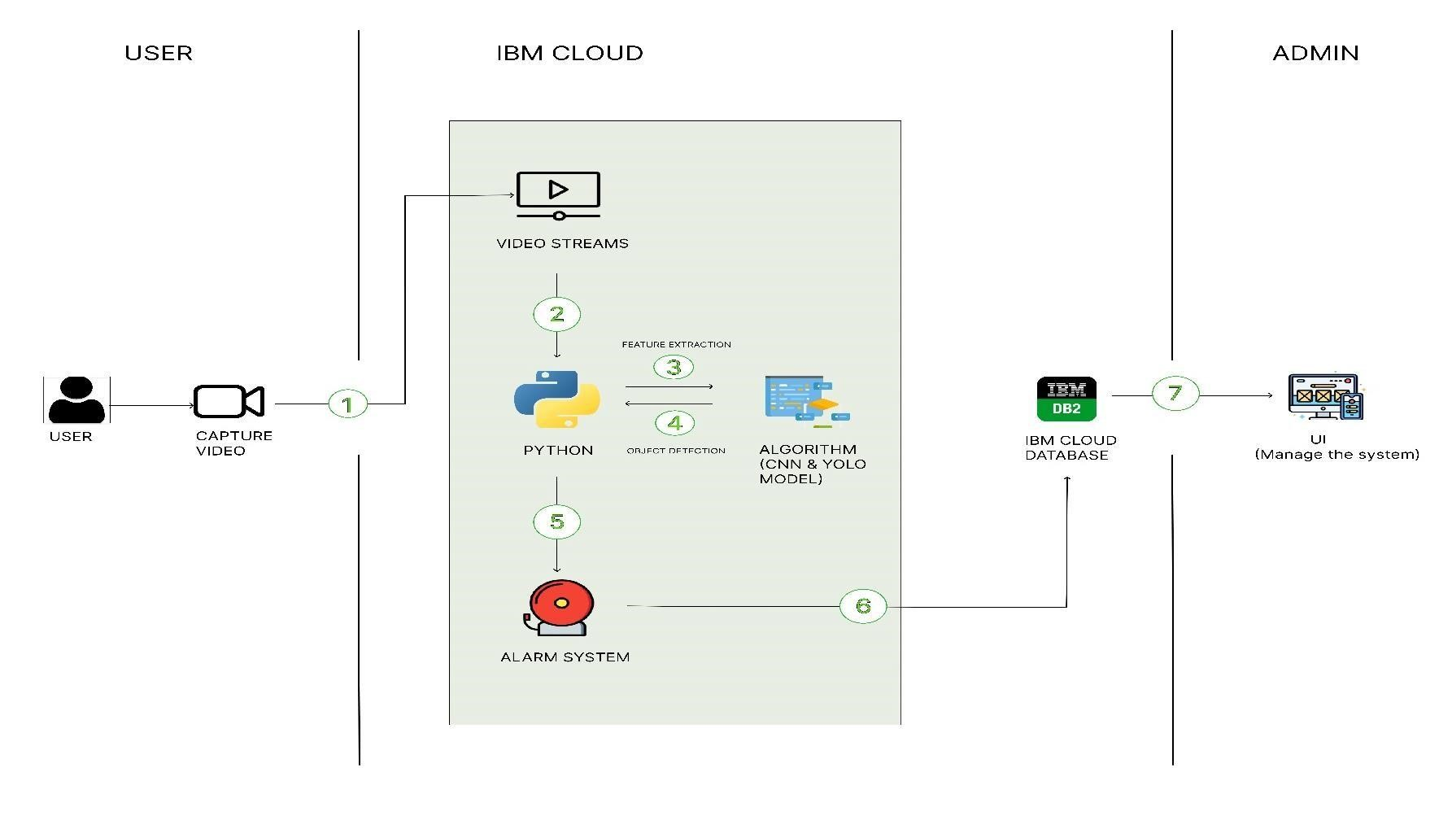

**Table-1: Components & Technologies:**

|  |  |  |  |
| --- | --- | --- | --- |
| **S. No** | **Component** | **Description** | **Technology** |
| 1. | User Interface | How user interacts with application | HTML, CSS, JavaScript / Angular Js / React Js etc. |
| 2. | Application Logic-1 | Pre-processing the model using datasets | Python |
| 3. | Application Logic-2 | Image extraction | Python |
| 4. | Application Logic-3 | Object detection | python |
| 5. | Database | Data Type, Configurations etc. | MySQL, NoSQL, etc. |
| 6. | Cloud Database | Database Service on Cloud | IBM DB2, IBM Cloudant etc. |
| 7. | File Storage | File storage requirements | IBM Block Storage or Other Storage Service or Local Filesystem |
| 8. | Deep Learning Model | Purpose of Deep Learning Model | Object Recognition Model, CNN etc. YOLOv7 model |
| 9. | Infrastructure (Server / Cloud) | Application Deployment on Local System / Cloud Local Server Configuration:  Cloud Server Configuration: | Local, Cloud Foundry etc., |

**Table-2: Application Characteristics:**

|  |  |  |  |
| --- | --- | --- | --- |
| **S. No** | **Characteristics** | **Description** | **Technology** |
| 1. | Open-Source Frameworks | Python (Anaconda) open-source frameworks used | python |
| 2. | Security Implementations | Camera under pools | AI |
| 3. | Scalable Architecture | 3 – tier Architecture | Python |
| 4. | Availability | All the time persons are under surveillance | AI |
| 5. | Performance | Many persons in the swimming pool will be detected whether the person is drowning or not | Python |